

Science Department

**Year 12 Chemistry ATAR**

**Test 5: Electrochemistry – Commercial Cells and Electrolysis**

Name: _____________________________

**Instructions to Students:**

1. 50 minutes permitted

2. Attempt all questions

3. Write in the spaces provided

4. Show all working when required

5. All answers to be in blue or black pen, diagrams in pencil.

|  |  |  |
| --- | --- | --- |
| **TOTAL** |  | **Final Percentage** |
| /66 |  |  |



**Year 12 Chemistry ATAR**

**Electrochemistry – Commercial Cells and Electrolysis**

1. Given these standard reduction potentials:

E° = −0.40 V for Cd2+(aq) + 2e−⇌ Cd(s)

E° = +0.80 V for Ag+(aq) + e− ⇌ Ag(s)

What is E° for the following reaction:

Cd(s) + 2 Ag+(aq) ⇌ Cd2+(aq) + 2 Ag(s) ?

A. +0.20 V

B. +0.40 V

C. +1.20 V

D. +2.00 V

2. During the discharge of a lead storage battery, both electrodes build up a layer of

A. Pb metal

B. PbO2

C. PbO

D. PbSO4

3. Given the standard reduction potentials, which statement is correct?

Cu2+(aq) + 2 e− ⇌ Cu(s)  E° = 0.34 V

2H+(aq) + 2 e− ⇌ H2(g) E° = 0.00 V

Cr3+(aq) + 3 e− ⇌ Cr(s) E° = –0.73 V

A. Cr(s) will react with acid.

B. Cu(s) will react with acid.

C. Cu2+(aq) will react with acid.

D. Cu(s) will react with Cr3+(aq).

**Use the following information to answer questions 4-6.**

A galvanic cell is constructed by placing a strip of zinc into a 1.0 mol L−1 solution of zinc nitrate and a strip of aluminum into a 1.0 mol L−1 solution of aluminum nitrate. The two metal strips are connected to a voltmeter by wires and a salt bridge connects the solutions. The temperature is 25°C. The following standard reduction potentials apply:

Al3+(aq) + 3e– *⇌* Al(s) *E*° = −1.67 V

Zn2+(aq) + 2e– *⇌* Zn(s) *E*° = −0.76 V

4. What is E° for the cell described above?

A 0.15 V

B 0.91 V

C -0.91 V

D 2.43 V

5. In the cell described above, where does reduction occur?

A. in the salt bridge

B. in the aluminum nitrate solution

C. at the zinc electrode

D. at the aluminum electrode

6. Considering the standard reduction potentials given in the box on the right, which of the following is the strongest reducing agent under standard conditions?

A Al(s)

B Al3+(aq)

C Zn(s)

D Zn2+(aq)

7. The Proton exchange membrane fuel cell which uses oxygen and hydrogen from the air is based on the spontaneous reaction that occurs when the following half-reactions are combined:

H2(g) → 2H+(aq) + 2e− E° = 0 V

O2(g) + 4H+(aq) + 4e− → 2H2O(l) E° = +1.23V

Which of the following statements regarding the oxygen-hydrogen fuel cell is true?

A. The hydrogen electrode is the anode.

B. The cell potential depends on pH.

C. Oxidation occurs at the oxygen electrode.

D. Electrons flow from the oxygen electrode to the hydrogen electrode.

8. When the appropriate electrodes are connected, the purpose of the salt bridge is to:

A. enable current to flow between two half cells by allowing electrons to flow through the salt bridge.

B. provide ammonium and nitrate ions to each half cell to maintain a constant pH in each half cell.

C. enable current to flow between two half cells by allowing ions to flow through the salt bridge.

D. provide ammonium and nitrate ions for the electrode reactions in each half cell.

9. Hydrogen peroxide can act as a reductant according to the half equation

O2(g) + 2H+(aq) + 2e– → H2O2(aq); E° = +0.70 V

Which of the following could all be reduced by hydrogen peroxide?

A. Fe2+(aq), Cu(s), I–(aq)

B. Ag+(aq), Br2(aq), H2O2(aq)

C. Ag(s), Br–(aq), Fe2+(aq)

D. I2(s), Cu2+(aq), Fe3+(aq)

10. If we compare a galvanic cell with an electrolytic cell, it is true to state that

A. in a galvanic cell reduction occurs at the negative electrode.

B. in both cells the anode is positive and the cathode is negative.

C. in an electrolytic cell oxidation occurs at the cathode.

D. in both cells reduction occurs at the cathode.

**Short Answer (56 marks)**

11. A 0.1 mol L-1  solution of HCl(aq)  is to be electrolysed using inert electrodes as shown.

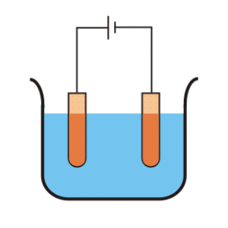

Determine the possible reactions at the anode and the cathode and give the overall reaction. Be sure to **include E° values.**

[3 marks]

|  |
| --- |
|  |
|  |
|  |
|  |
|  |
|  |
|  |
|  |

12. Predict the anode and cathode reaction and write a balanced overall equation for the following cells. Also calculate the cell EMF (N.B. The cell is not necessarily written with the anode on the left.) No states required.

(a) Pt | Br-1 | Br2 || Cu | Cu+2

(b) Mg | Mg+2 || Cu+2 | Cu

[6 marks]

13. A tin rod dipping into a 1M Sn(NO3)­2 and a cobalt rod dipping into 1M CoSO4 solution are connected to a voltmeter (a salt bridge is included). Draw a large diagram of the circuit, indicating the flow of electrons, the anode and the cathode, the sign on each electrode, the overall E° of the cell, the movement of ions in each cell, the flow of ions across the salt bridge, the electrode that loses mass and the electrode gaining mass (if any).

Also write the overall equation for the cell.

[10 marks]

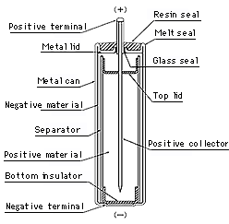14. One of the many practical applications of electrochemical cell theory is in the construction of dry cell “batteries”. Over the years, companies have tried different chemical compounds to move beyond the original zinc/carbon primary cell to rechargeable secondary cells of more advanced construction.

One such cell is the Lithium Thionyl Chloride cell. This “battery” is ideal for such long-term applications as power for electronic devices and electric power, water, and gas meters, and especially as a backup power source for memory integrated circuits.

*Construction of the Lithium Thionyl Chloride cell*

The equations involved with this type of cell are:

1. Li —> Li+ + e-1 E° = 3.045V

2. 4Li+ + 4e- + 2SOCl2 —> 4LiCl + SO2 + S E° = 0.555V

(a) Give the overall cell reaction.

|  |
| --- |
|  |

(b) State the expected EMF of the cell.

|  |
| --- |
|  |

(c) Despite their high output voltage, you are not able to buy these “Batteries” at the supermarket, and are only available as in-built batteries for special devices. What is a potential safety concern with this type of battery?

|  |
| --- |
|  |
|  |
|  |
|  |

(d) These type of cells are known as “secondary” cells. Why is this?

|  |
| --- |
|  |
|  |

(e) List two advantages and disadvantages of secondary cells as opposed to traditional primary cells.

|  |
| --- |
|  |
|  |
|  |
|  |

[9 marks]

15. One of the many practical applications of electrochemical cell theory is in the construction of the lead-acid accumulator battery. A cell can be constructed from two lead plates, and a concentrated sulfuric acid solution. After the plates are added to the acid, a deposit forms on the surface of the lead plates. The cell is then charged electrolytically, and the deposit on the surface of the plates changes chemically.

Once charged, the cell can be discharged, giving off a useable voltage. Use your standard reduction potential table to help you answer the following, **states required:**

1. Give the anode half equation during DISCHARGE and the E°.

|  |
| --- |
|  |
|  |

(b) Give the cathode half equation during DISCHARGE and the E°.

|  |
| --- |
|  |
|  |

(c) Give the overall cell reaction.

|  |
| --- |
|  |

(d) State the expected EMF of the cell.

|  |
| --- |
|  |

(e) Car batteries are lead-acid accumulators; they have a voltage of 12V. How is this achieved in light of your answer to (d).

|  |
| --- |
|  |
|  |
|  |
|  |

(f) List two advantages and disadvantages of a lead-acid battery.

|  |
| --- |
|  |
|  |
|  |
|  |

[11 marks]

16.The diagram below is a simplified, incomplete, representation of the final stage of copper purification, where the electrorefining of copper metal is carried out.

- power +

source

Z

X

Y

(a) Why is a power source required for this process?

|  |
| --- |
|  |
|  |
|  |
|  |

(b) Give the name or formula of the substance that would be used for;

X ______________________________________

Y ______________________________________

Z ______________________________________

(c) Which letter denotes the cathode? ____________

(d) Write the half equation for the reaction occurring at X.

|  |
| --- |
|  |

(e) Why would AgNO3(aq) be an inappropriate substance to use for Y?

|  |
| --- |
|  |
|  |
|  |
|  |

[8 marks]

17. A car manufacturer is planning to sell hybrid cars powered by a type of hydrogen fuel cell connected to a metal hydride, NiMH Battery.

A representation of the hydrogen fuel cell is given below:

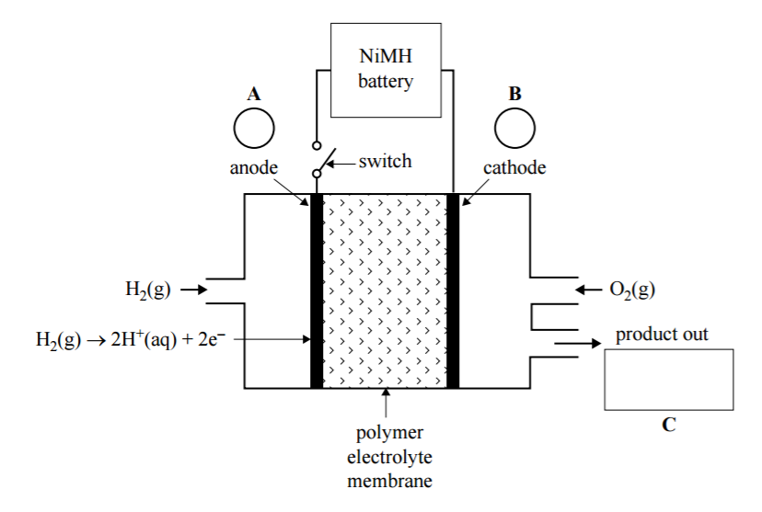

E

C

D

B

A

1. What is the overall cell reaction for the fuel cell component of this vehicle power plant?

______________________________________________________________

1. On the diagram above, indicate the anode and cathode, in boxes A and B, polarity of the anode and cathode in circles C and D, and identify the product of the reaction in box E.
2. Write an equation for the reaction that occurs at the cathode when the switch is closed.

______________________________________________________________

1. Identify one advantage and one disadvantage of using this fuel cell instead of a petrol engine to power the car.

Advantage: ____________________________________________________

______________________________________________________________

Disadvantage: __________________________________________________

______________________________________________________________

[9 marks]

**END OF TEST**